Java Problemsheet - 9

Name: Kaaviya S S Roll. no: 22PT15

1. Develop a AWT & Swings program to draw different shapes and filled with colors as well.

import javax.swing.*;
import java.awt.*;

class ShapeDrawing extends JFrame
{
public ShapeDrawing() {
setTitle("Shape Drawing Frame");
setSize(900,600);
setDefaultCloseOperation(JFrame.EXIT_ON_CLOSE);
setLayout(null);
setLocation(300,300);
}

@Override
public void paint(Graphics g) {
super.paint(g);
// Draw a rectangle
g.setColor(Color.BLUE);
g.drawRect(50, 50, 200, 100);
g.fillRect(50, 50, 200, 100);

// Draw an oval
g.setColor(Color.GREEN);
g.drawOval(300, 50, 200, 100);
g.fillOval(300, 50, 200, 100);

// Draw a polygon
g.setColor(Color.YELLOW);
int[] x = {600, 600, 800};
int[] y = {50, 150, 150};
int numPoints = 3;
g.drawPolygon(x, y, numPoints);
g.fillPolygon(x, y, numPoints);
}

public static void main(String[] args) {
new ShapeDrawing().setVisible(true);
}
}

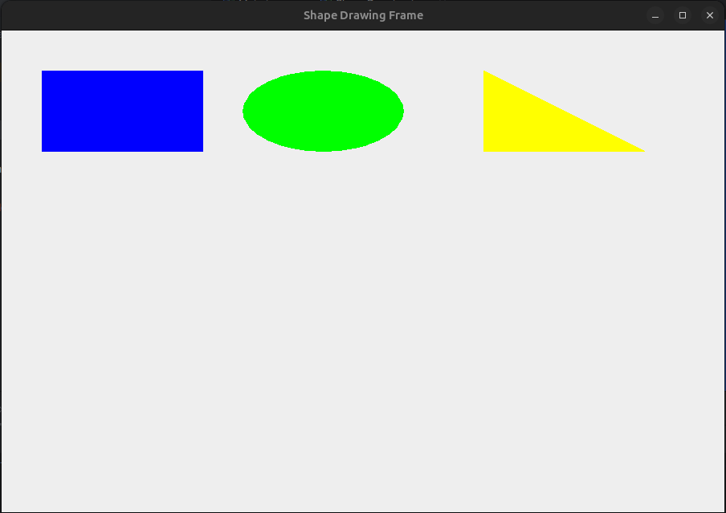

—----------------------------------------------------------------------------------------------------------------------------

2. Develop a AWT & Swings program to draw different smileys

import javax.swing.*;
import java.awt.*;

class DrawSmiley extends JFrame {
public DrawSmiley() {
setTitle("Drawing Smileys");
setSize(800,400);
setDefaultCloseOperation(JFrame.EXIT_ON_CLOSE);
setLayout(null);
setLocation(100,100);

// Add labels for happy and sad faces
JLabel happy = new JLabel("Happy Face");
happy.setBounds(80, 0, 100, 30);
add(happy);
JLabel sad = new JLabel("Sad Face");
sad.setBounds(300, 0, 100, 30);
add(sad);
JLabel neutral = new JLabel("Neutral Face");
neutral.setBounds(480, 0, 100, 30);
add(neutral);
}

@Override
public void paint(Graphics g) {
super.paint(g);
// Happy face
g.setColor(Color.YELLOW);
g.drawOval(50, 50, 150, 150);
g.fillOval(50, 50, 150, 150);

g.setColor(Color.BLACK);
g.drawOval(80, 90, 20, 20);
g.fillOval(80, 90, 20, 20);
g.setColor(Color.BLACK);
g.drawOval(140, 90, 20, 20);
g.fillOval(140, 90, 20, 20);

g.setColor(Color.BLACK);
g.drawArc(80, 120, 90, 50, 0, -180);

// Sad face
g.setColor(Color.YELLOW);
g.drawOval(250, 50, 150, 150);
g.fillOval(250, 50, 150, 150);

g.setColor(Color.BLACK);
g.drawOval(280, 90, 20, 20);
g.fillOval(280, 90, 20, 20);
g.setColor(Color.BLACK);
g.drawOval(340, 90, 20, 20);
g.fillOval(340, 90, 20, 20);

g.setColor(Color.BLACK);
g.drawArc(280, 130, 90, 50, 0, 180);

// Neutral face
g.setColor(Color.YELLOW);
g.drawOval(450, 50, 150, 150);
g.fillOval(450, 50, 150, 150);

g.setColor(Color.BLACK);
g.drawOval(480, 90, 20, 20);
g.fillOval(480, 90, 20, 20);
g.setColor(Color.BLACK);
g.drawOval(540, 90, 20, 20);
g.fillOval(540, 90, 20, 20);

g.setColor(Color.BLACK);
g.drawLine(490, 150, 555,150);
}

public static void main(String[] args) {
new DrawSmiley().setVisible(true);
}
}

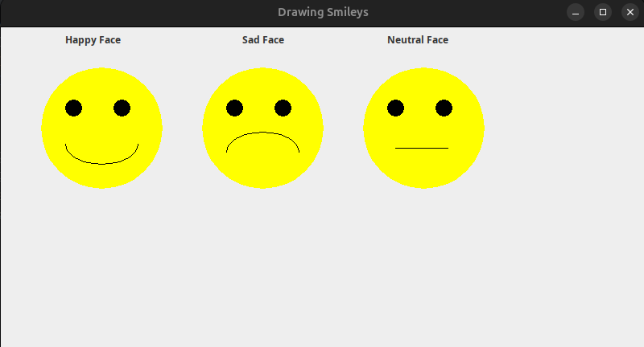

—----------------------------------------------------------------------------------------------------------------------------

3. Develop a GUI (AWT, Swings & JavaFX) application that calculates the future value of an investment at a given interest rate for a specified number of years. The formula for the
calculation is:
futureValue = investmentAmount * (1 + monthlyInterestRate)years*12
Use text fields for the investment amount, number of years, and annual interest rate. Display the future amount in a text field when the user clicks the Calculate button.

import javax.swing.*;
import java.awt.*;
import java.awt.event.*;

class InvestmentCalculator extends JFrame {

JTextField textInvestmentAmount, textYears, textInterestRate, textFutureValue;

InvestmentCalculator()
{
setTitle("Investment calculator");
setSize(600,400);
setDefaultCloseOperation(JFrame.EXIT_ON_CLOSE);
setLayout(null);
setLocation(100,100);

//-------------------------------------------------
JLabel labelInvestmentAmount = new JLabel("Investment Amount:");
labelInvestmentAmount.setBounds(60, 20, 150, 27);
add(labelInvestmentAmount);

textInvestmentAmount = new JTextField();
textInvestmentAmount.setBounds(200, 20, 150, 27);
add(textInvestmentAmount);

//-------------------------------------------------
JLabel labelYears = new JLabel("Number of Years:");
labelYears.setBounds(60, 60, 150, 27);
add(labelYears);

textYears = new JTextField();
textYears.setBounds(200, 60, 150, 27);
add(textYears);

//--------------------------------------------------
JLabel labelInterestRate = new JLabel("Annual Interest Rate (%):");
labelInterestRate.setBounds(60, 100, 150, 27);
add(labelInterestRate);

textInterestRate = new JTextField();
textInterestRate.setBounds(200, 100, 150, 27);
add(textInterestRate);

//--------------------------------------------------
JButton Calculate = new JButton("Calculate");
Calculate.setBounds(100, 150, 150, 30);
Calculate.setBackground(Color.BLACK);
Calculate.setForeground(Color.WHITE);
add(Calculate);

// Add action listener to the button
Calculate.addActionListener(new ActionListener()
{
public void actionPerformed(ActionEvent ae) {
calculateFutureValue();
}
});

//--------------------------------------------------
JLabel labelFutureValue = new JLabel("Future Value:");
labelFutureValue.setBounds(60, 220, 150, 27);
labelFutureValue.setForeground(Color.BLUE);
labelFutureValue.setFont(new Font("Arial", Font.PLAIN, 18));
add(labelFutureValue);

textFutureValue = new JTextField();
textFutureValue.setBounds(200, 220, 150, 27);
textFutureValue.setFocusable(false);
add(textFutureValue);

//--------------------------------------------------
}

public void calculateFutureValue()
{
double investmentAmount = Double.parseDouble(textInvestmentAmount.getText());
int years = Integer.parseInt(textYears.getText());
double annualInterestRate = Double.parseDouble(textInterestRate.getText());

double monthlyInterestRate = annualInterestRate/12;

double futureValue = investmentAmount * Math.pow((1 + monthlyInterestRate), years*12);

textFutureValue.setText(String.format("%.2f", futureValue));
}

public static void main(String[] args) {
new InvestmentCalculator().setVisible(true);
}
}

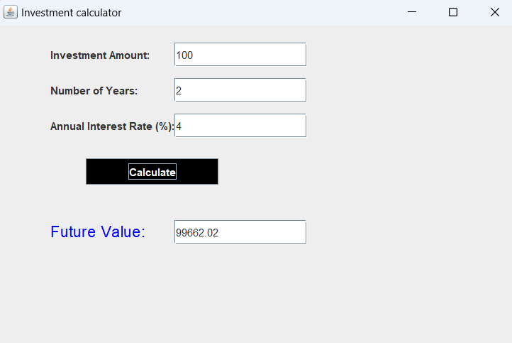

—----------------------------------------------------------------------------------------------------------------------------

4. Develop a GUI (AWT, Swings & JavaFX) application that lets the user enter a file name in the text field and press the Enter key to display its binary representation in a text area. The user can also modify the binary code and save it back to the file, as shown in below.
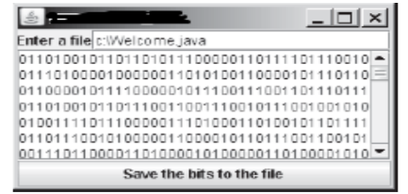
import javax.swing.*;
import java.io.*;
import java.nio.file.Files;
import java.nio.file.Paths;
import java.awt.event.*;

public class BinaryFileEditor extends JFrame {

JTextField fileName;
JTextArea binaryData;

BinaryFileEditor()
{
setTitle("Binary File Editor");
setSize(500,300);
setDefaultCloseOperation(JFrame.EXIT_ON_CLOSE);
setLayout(null);
setLocation(200,100);

//---------------------------------------------------
JLabel labelFilename = new JLabel("Enter a file:");
labelFilename.setBounds(10, 10, 100, 25);
add(labelFilename);

fileName = new JTextField();
fileName.setBounds(100, 10, 370, 25);
add(fileName);

fileName.addActionListener(new ActionListener() {
public void actionPerformed(ActionEvent e) {
loadFile(); // Call loadFile() when Enter is pressed in fileNameField
}
});

//---------------------------------------------------
binaryData = new JTextArea();
binaryData.setEditable(true);
add(binaryData);

JScrollPane scrollPane = new JScrollPane(binaryData);
scrollPane.setBounds(10, 45, 460, 150);
add(scrollPane);

//---------------------------------------------------
JButton saveFile = new JButton("Save the bits to the file");
saveFile.setBounds(10, 210, 460,20);
add(saveFile);

saveFile.addActionListener(new ActionListener() {

public void actionPerformed(ActionEvent ae) {
saveToFile();
}
});
//----------------------------------------------------
}

public void loadFile() {
String fname = fileName.getText().trim();
try {
byte[] bytes = Files.readAllBytes(Paths.get(fname));
StringBuilder binaryStringBuilder = new StringBuilder();

for (byte b : bytes) {
binaryStringBuilder.append(
String.format("%8s", Integer.toBinaryString(b & 0xFF)).
replace(' ', '0')).
append("\n");
}

binaryData.setText(binaryStringBuilder.toString());
}
catch (IOException ex) {
JOptionPane.showMessageDialog(this, "Error reading file: " + ex.getMessage(), "File Error", JOptionPane.ERROR_MESSAGE);
}
}

public void saveToFile() {
String filename = fileName.getText().trim();

try {
String[] lines = binaryData.getText().split("\\n");
ByteArrayOutputStream output = new ByteArrayOutputStream();
for (String line : lines) {
byte b = (byte) Integer.parseInt(line.trim(), 2);
output.write(b);
}
Files.write(Paths.get(filename), output.toByteArray());
JOptionPane.showMessageDialog(this, "File saved successfully.", "Success", JOptionPane.INFORMATION_MESSAGE);
}
catch (IOException e) {
JOptionPane.showMessageDialog(this, "Error saving file: " + e.getMessage(), "File Error", JOptionPane.ERROR_MESSAGE);
}
}

public static void main(String[] args) {
new BinaryFileEditor().setVisible(true);
}
}

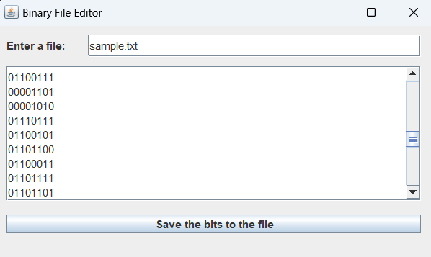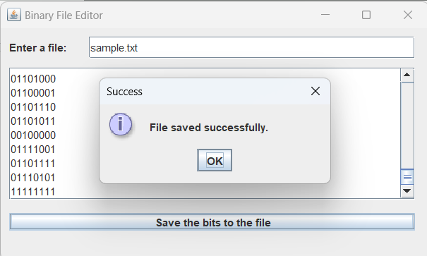

—----------------------------------------------------------------------------------------------------------------------------

5. Write a Software Phone App using (AWT, Swings & JavaFX) as illustrated in the figure. The user enters the phone number and pushes the "CALL" button to start a phone call. Once the call is started, the label of the "CALL" button changes to "HANG UP". When the user hangs up, the display is cleared.
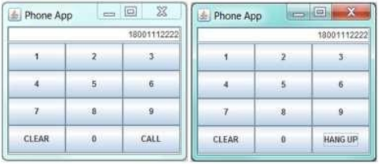

import javax.swing.*;
import java.awt.*;
import java.awt.event.*;

public class SoftwarePhoneApp extends JFrame {

JTextField phoneNumber;
JButton call_hang;

SoftwarePhoneApp()
{
setTitle("Software phone app");
setSize(300, 280);
setDefaultCloseOperation(JFrame.EXIT_ON_CLOSE);
setLocation(200,200);
setLayout(null);

//------------------------------------------------------
phoneNumber = new JTextField();
phoneNumber.setBounds(10, 10, 270, 25);
add(phoneNumber);

//------------------------------------------------------
JButton one = new JButton("1");
one.setBounds(10, 40, 90, 40);
one.addActionListener(new NumberButton("1"));
add(one);

JButton two = new JButton("2");
two.setBounds(100, 40, 90, 40);
two.addActionListener(new NumberButton("2"));
add(two);

JButton three = new JButton("3");
three.setBounds(190, 40, 90, 40);
three.addActionListener(new NumberButton("3"));
add(three);

JButton four = new JButton("4");
four.setBounds(10, 80, 90, 40);
four.addActionListener(new NumberButton("4"));
add(four);

JButton five = new JButton("5");
five.setBounds(100, 80, 90, 40);
five.addActionListener(new NumberButton("5"));
add(five);

JButton six = new JButton("6");
six.setBounds(190, 80, 90, 40);
six.addActionListener(new NumberButton("6"));
add(six);

JButton seven = new JButton("7");
seven.setBounds(10, 120, 90, 40);
seven.addActionListener(new NumberButton("7"));
add(seven);

JButton eight = new JButton("8");
eight.setBounds(100, 120, 90, 40);
eight.addActionListener(new NumberButton("8"));
add(eight);

JButton nine = new JButton("9");
nine.setBounds(190, 120, 90, 40);
nine.addActionListener(new NumberButton("9"));
add(nine);

JButton clear = new JButton("CLEAR");
clear.setBounds(10, 160, 90, 40);
clear.addActionListener(new ActionListener() {
public void actionPerformed(ActionEvent e) {
phoneNumber.setText("");
}
});
add(clear);

JButton zero = new JButton("0");
zero.setBounds(100, 160, 90, 40);
zero.addActionListener(new NumberButton("0"));
add(zero);

call_hang = new JButton("CALL");
call_hang.setBounds(190, 160, 90, 40);
call_hang.addActionListener(new ActionListener()
{
public void actionPerformed(ActionEvent e) {
if (call_hang.getText().equals("CALL")) {
call_hang.setText("HANG UP");
}

else if (call_hang.getText().equals("HANG UP"))
{
call_hang.setText("CALL");
phoneNumber.setText("");
}
call_hang.repaint();
}
});
add(call_hang);
}

class NumberButton implements ActionListener {
String number;
NumberButton(String num) {
this.number = num;
}
public void actionPerformed(ActionEvent e) {
phoneNumber.setText(phoneNumber.getText() + number);
}
}

public static void main(String[] args) {
new SoftwarePhoneApp().setVisible(true);
}
}

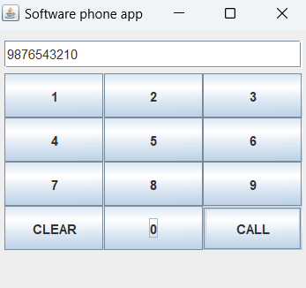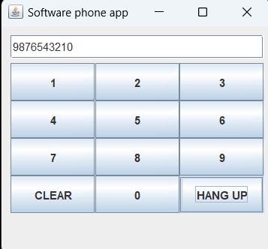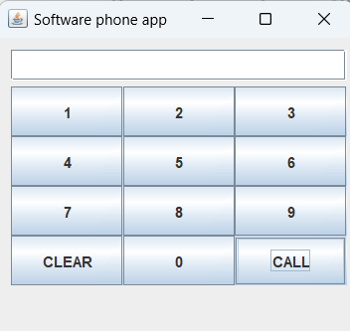

—----------------------------------------------------------------------------------------------------------------------------

6. Write a program that moves the ball in a panel using (AWT, Swings & JavaFX). You should define a panel class for displaying the ball and provide the methods for moving the ball left, right, up, and down, as shown in below figure. Check the boundary to prevent the ball from moving out of sight completely.
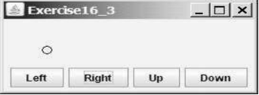

import javax.swing.*;
import java.awt.*;
import java.awt.event.*;

public class BallMovement extends JFrame {

JPanel ballPanel;
int x = 100;
int y = 150;
int radius = 10;

BallMovement()
{
setTitle("Ball Movement");
setSize(500, 300);
setDefaultCloseOperation(JFrame.EXIT_ON_CLOSE);
setLocation(200,200);
setLayout(null);

//-----------------------------------------------------
JButton leftButton = new JButton("Left");
leftButton.setBounds(10, 200, 100, 20);
leftButton.addActionListener(new ActionListener()
{
public void actionPerformed(ActionEvent e) {
moveLeft();
}
});
add(leftButton);

JButton rightButton = new JButton("Right");
rightButton.setBounds(120, 200, 100, 20);
rightButton.addActionListener(new ActionListener()
{
public void actionPerformed(ActionEvent e) {
moveRight();
}
});
add(rightButton);

JButton upButton = new JButton("Up");
upButton.setBounds(240, 200, 100, 20);
upButton.addActionListener(new ActionListener()
{
public void actionPerformed(ActionEvent e) {
moveUp();
}
});
add(upButton);

JButton downButton = new JButton("Down");
downButton.setBounds(360, 200, 100, 20);
downButton.addActionListener(new ActionListener()
{
public void actionPerformed(ActionEvent e) {
moveDown();
}
});
add(downButton);

}

@Override
public void paint(Graphics g)
{
super.paint(g);
g.drawOval(x,y, 2*radius, 2*radius);
}

public void moveLeft() {
if(x > 0) {
x -= 20;
this.repaint();
}
}

public void moveRight() {
if(x + radius*2 < getWidth()) {
x += 20;
this.repaint();
}
}

public void moveUp() {
if(y > 0) {
y -= 20;
this.repaint();
}
}

public void moveDown() {
if(y + radius*2 < getHeight()) {
y += 20;
this.repaint();
}
}

public static void main(String[] args) {
new BallMovement().setVisible(true);
}
}

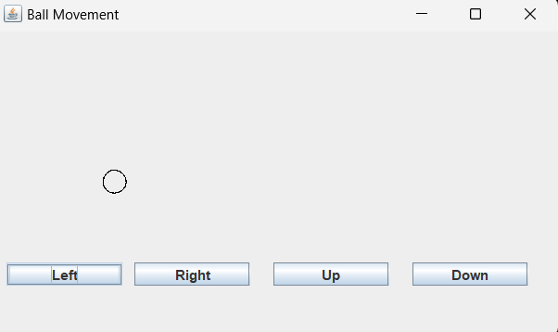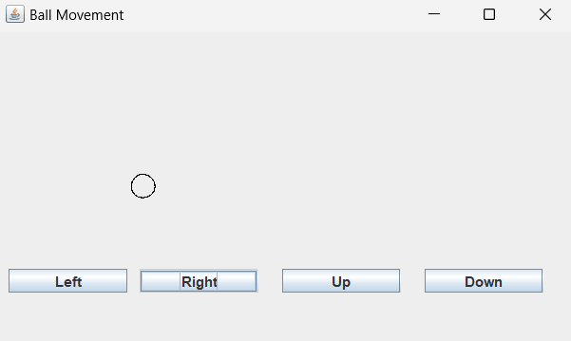
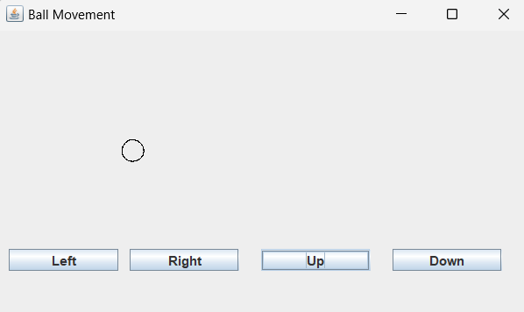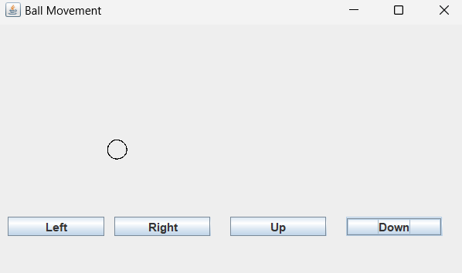

—----------------------------------------------------------------------------------------------------------------------------

7. Develop a simple calculator using Swings & JavaFX components.

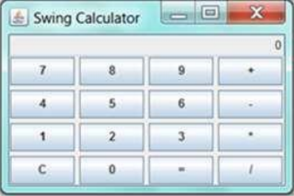

import javax.swing.*;
import java.awt.*;
import java.awt.event.*;

public class Calculator extends JFrame {

JTextField display;
double firstNumber = 0;
double secondNumber = 0;
String operator = "";

Calculator()
{
setTitle("Simple Calculator");
setSize(500, 300);
setDefaultCloseOperation(JFrame.EXIT_ON_CLOSE);
setLocation(200,200);
setLayout(new BorderLayout());

display = new JTextField("");
display.setEditable(false);
display.setFont(new Font("Arial", Font.BOLD, 24));
display.setHorizontalAlignment(JTextField.RIGHT);
display.setPreferredSize(new Dimension(500, 50));
add(display, BorderLayout.NORTH);

// Panel for calculator buttons (4x4 grid)
JPanel buttonPanel = new JPanel();
buttonPanel.setLayout(new GridLayout(4, 4, 5, 5)); // 4x4 grid with 5px gaps

// Buttons for digits 7-9 and '+'
buttonPanel.add(createButton("7"));
buttonPanel.add(createButton("8"));
buttonPanel.add(createButton("9"));
buttonPanel.add(createOperatorButton("+"));

// Buttons for digits 4-6 and '-'
buttonPanel.add(createButton("4"));
buttonPanel.add(createButton("5"));
buttonPanel.add(createButton("6"));
buttonPanel.add(createOperatorButton("-"));

// Buttons for digits 1-3 and '*'
buttonPanel.add(createButton("1"));
buttonPanel.add(createButton("2"));
buttonPanel.add(createButton("3"));
buttonPanel.add(createOperatorButton("*"));

// Buttons for 'C', '0', '=', and '/'
buttonPanel.add(createClearButton("C")); // Clear button
buttonPanel.add(createButton("0"));
buttonPanel.add(createEqualsButton("=")); // Equals button
buttonPanel.add(createOperatorButton("/"));

add(buttonPanel, BorderLayout.CENTER);

// for spacing after last set of buttons
JPanel spacerPanel = new JPanel();
spacerPanel.setPreferredSize(new Dimension(0, 10));
add(spacerPanel, BorderLayout.SOUTH);
}

public JButton createButton(String num) {
JButton button = new JButton(num);
button.addActionListener (new ActionListener()
{
public void actionPerformed(ActionEvent e) {
display.setText(display.getText() + num); // Append the button's label to the display
}
});
return button;
}

public JButton createClearButton(String label) {
JButton button = new JButton(label);
button.addActionListener (new ActionListener()
{
public void actionPerformed(ActionEvent e) {
display.setText("");
firstNumber = 0;
secondNumber = 0;
operator = "";
}
});
return button;
}

public JButton createOperatorButton(String op) {
JButton button = new JButton(op);
button.addActionListener (new ActionListener()
{
public void actionPerformed(ActionEvent e)
{
operator = op;
display.setText(display.getText() + " " + operator + " ");
}
});
return button;
}

public JButton createEqualsButton(String op) {
JButton button = new JButton(op);
button.addActionListener (new ActionListener()
{
public void actionPerformed(ActionEvent e)
{
String[] parts = display.getText().split(" "); // Split by space to separate first number, operator, and second number
if (parts.length == 3) {
firstNumber = Double.parseDouble(parts[0]); // First number
operator = parts[1]; // Operator
secondNumber = Double.parseDouble(parts[2]); // Second number
}
double result = 0;

switch (operator)
{
case "+": result = firstNumber + secondNumber;
break;
case "-": result = firstNumber - secondNumber;
break;
case "*": result = firstNumber * secondNumber;
break;
case "/": if (secondNumber != 0) {
result = firstNumber / secondNumber;
} else {
display.setText("Error"); // Display error if dividing by 0
return;
}
break;
}
display.setText(String.valueOf(result));
firstNumber = result;
}
});
return button;
}

public static void main(String[] args) {
new Calculator().setVisible(true);
}
}

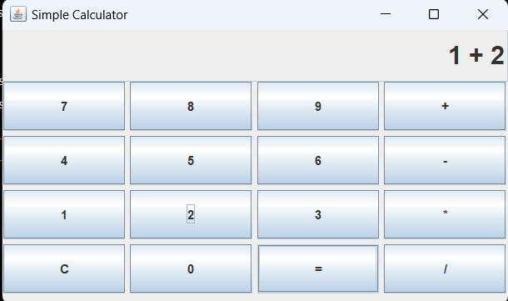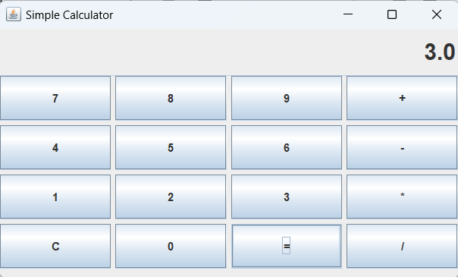

—----------------------------------------------------------------------------------------------------------------------------

9. Draw an Olympic symbol using AWT & Swings shown below Figure.

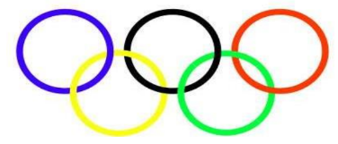

import javax.swing.*;
import java.awt.*;
import java.awt.geom.Ellipse2D;

public class OlympicRings extends JFrame {

OlympicRings() {
setTitle("Olympic Rings");
setSize(500, 300);
setDefaultCloseOperation(JFrame.EXIT_ON_CLOSE);
setLocationRelativeTo(null); // Center the window
}

@Override
public void paint(Graphics g) {
super.paint(g);
drawOlympicRings(g);
}

public void drawOlympicRings(Graphics g)
{
Graphics2D g2d = (Graphics2D) g;
g2d.setStroke(new BasicStroke(5)); // Set line width to 5

// Draw the circle
int diameter = 100; // Diameter of the circle
int xOffset = 50; // X coordinate for the top left corner
int yOffset = 50; // Y coordinate for the top left corner

g2d.setColor(Color.BLUE);
g2d.draw(new Ellipse2D.Double(xOffset, yOffset, diameter, diameter));

g2d.setColor(Color.BLACK);
g2d.draw(new Ellipse2D.Double(xOffset + 120, yOffset, diameter, diameter));

g2d.setColor(Color.RED);
g2d.draw(new Ellipse2D.Double(xOffset + 240 , yOffset, diameter, diameter));

g2d.setColor(Color.YELLOW);
g2d.draw(new Ellipse2D.Double(xOffset + 60, yOffset + 60, diameter, diameter));

g2d.setColor(Color.GREEN);
g2d.draw(new Ellipse2D.Double(xOffset + 180, yOffset + 60, diameter, diameter));
}

public static void main(String[] args) {
new OlympicRings().setVisible(true);
}
}

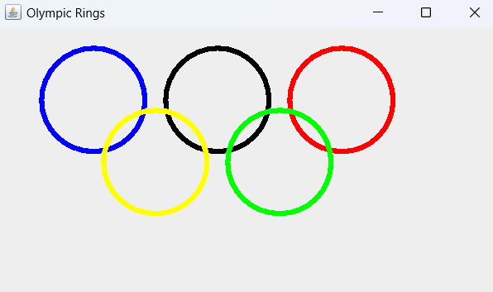

—----------------------------------------------------------------------------------------------------------------------------

8. Write a program using Swings & JavaFX components that displays the calendar for the
Current month. You can use the Prior and Next buttons to show the calendar of the previous or next month. Display the dates in the current month in black and display the dates in the previous month and next month in gray.
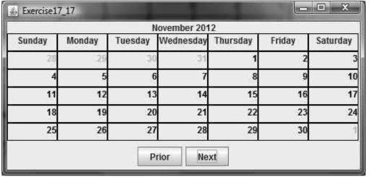

import javax.swing.*;
import java.awt.*;
import java.awt.event.*;
import java.util.Calendar;
import java.util.GregorianCalendar;

public class CalenderApp extends JFrame {

JPanel calendarPanel;
JLabel monthLabel;
int currentMonth, currentYear;
JButton previousButton, nextButton;

CalenderApp()
{
setTitle("Calendar");
setSize(500, 350);
setDefaultCloseOperation(JFrame.EXIT_ON_CLOSE);
setLocation(200,200);
setLayout(new BorderLayout());

previousButton = new JButton("Previous");
previousButton.addActionListener(new ChangeMonth());
nextButton = new JButton("Next");
nextButton.addActionListener(new ChangeMonth());

JPanel bottomPanel = new JPanel();
bottomPanel.setLayout(new FlowLayout(FlowLayout.CENTER)); //to center the button bottom center
bottomPanel.add(previousButton);
bottomPanel.add(nextButton);
add(bottomPanel, BorderLayout.SOUTH);
//---------------------------------------------------------

monthLabel = new JLabel("", SwingConstants.CENTER);
monthLabel.setFont(new Font("Arial", Font.BOLD, 16));
add(monthLabel, BorderLayout.NORTH);
//---------------------------------------------------------

calendarPanel = new JPanel();
calendarPanel.setLayout(new GridLayout(0, 7));

Calendar calendar = Calendar.getInstance();
currentMonth = calendar.get(Calendar.MONTH);
currentYear = calendar.get(Calendar.YEAR);

add(calendarPanel, BorderLayout.CENTER);

displayCalendar(currentMonth, currentYear);
}

public void displayCalendar(int month, int year)
{
calendarPanel.removeAll();

monthLabel.setText(new GregorianCalendar(year, month, 1)
.getDisplayName(Calendar.MONTH, Calendar.LONG, getLocale()) + " " + year);

String[] daysOfWeek = {"Sunday", "Monday", "Tuesday", "Wednesday", "Thursday", "Friday", "Saturday"};
for (String day : daysOfWeek) {
JLabel dayLabel = new JLabel(day, SwingConstants.CENTER);
dayLabel.setFont(new Font("Arial", Font.BOLD, 12));
calendarPanel.add(dayLabel);
}

// Get the first day of the month
Calendar calendar = new GregorianCalendar(year, month, 1);
int firstDayOfWeek = calendar.get(Calendar.DAY_OF_WEEK);
int daysInMonth = calendar.getActualMaximum(Calendar.DAY_OF_MONTH);

// Get the previous month's last day
calendar.set(Calendar.MONTH, month - 1);
int daysInPreviousMonth = calendar.getActualMaximum(Calendar.DAY_OF_MONTH);

// Fill in previous month's days
for (int i = 1; i < firstDayOfWeek; i++) {
JLabel label = new JLabel(String.valueOf(daysInPreviousMonth - (firstDayOfWeek - i)));
label.setForeground(Color.GRAY);
label.setHorizontalAlignment(SwingConstants.CENTER);
calendarPanel.add(label);
}

// Fill in current month's days
for (int day = 1; day <= daysInMonth; day++) {
JLabel label = new JLabel(String.valueOf(day));
label.setForeground(Color.BLACK);
label.setHorizontalAlignment(SwingConstants.CENTER);
calendarPanel.add(label);
}

// Fill in next month's days
int totalCells = 42; // 6 weeks
int daysToFill = totalCells - (firstDayOfWeek - 1 + daysInMonth);
for (int day = 1; day <= daysToFill; day++) {
JLabel label = new JLabel(String.valueOf(day));
label.setForeground(Color.GRAY);
label.setHorizontalAlignment(SwingConstants.CENTER);
calendarPanel.add(label);
}

calendarPanel.revalidate();
calendarPanel.repaint();
}

class ChangeMonth implements ActionListener {
public void actionPerformed(ActionEvent e)
{
if (e.getSource() == previousButton) {
if (currentMonth == 0) {
currentMonth = 11; // December
currentYear--;
} else {
currentMonth--;
}
}
else if (e.getSource() == nextButton) {
if (currentMonth == 11) {
currentMonth = 0; // January
currentYear++;
} else {
currentMonth++;
}
}
displayCalendar(currentMonth, currentYear);
}
}

public static void main(String[] args) {
new CalenderApp().setVisible(true);
}
}

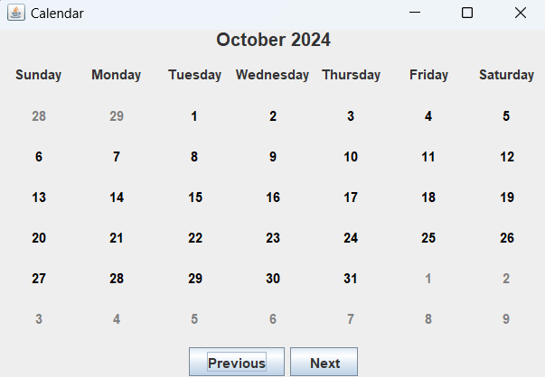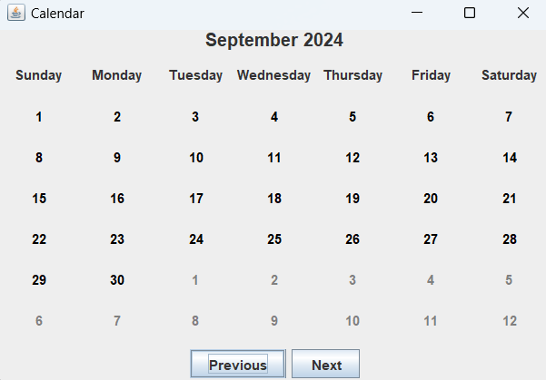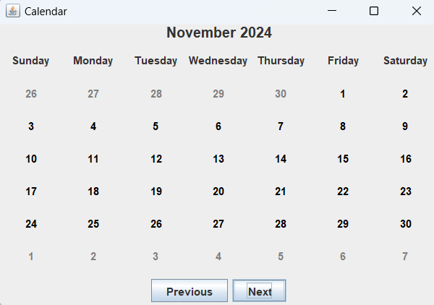

—----------------------------------------------------------------------------------------------------------------------------

12. Design an JavaFX application to generate a chessboard output shown in below Figure.
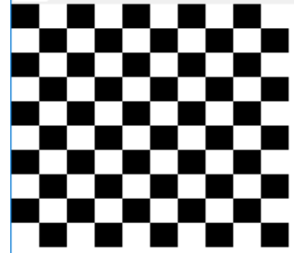

import javax.swing.*;
import java.awt.*;

public class Chessboard extends JFrame {

Chessboard() {
setTitle("Chessboard");
setSize(500, 500);
setDefaultCloseOperation(JFrame.EXIT_ON_CLOSE);
setLocation(200,200);
setLayout(new GridLayout(10, 10)); // 8x8 grid for chessboard

// Create the chessboard using alternating colors
for (int row = 0; row < 10; row++) {
for (int col = 0; col < 10; col++) {
JPanel square = new JPanel();

// Set color based on row and column
if ((row + col) % 2 == 1) {
square.setBackground(Color.WHITE);
} else {
square.setBackground(Color.BLACK);
}

// Add the square to the JFrame
add(square);
}
}
}

public static void main(String[] args) {
new Chessboard().setVisible(true);
}
}

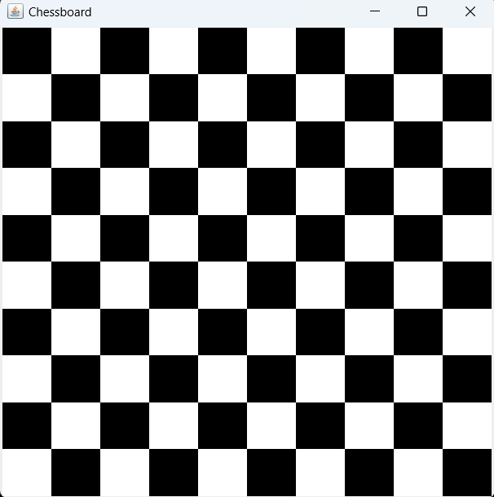

—----------------------------------------------------------------------------------------------------------------------------

13. Design an order form using Swing & JavaFX components as shown below and implement the necessary business rule.
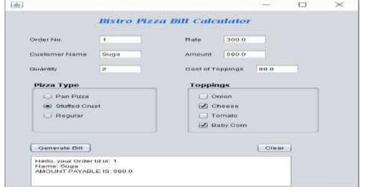

import javax.swing.*;
import java.awt.*;
import java.awt.event.*;

public class PizzaBill extends JFrame
{
JTextField orderNo, rate, Name, amount, quantity, CostToppings;
JRadioButton PanPizza, StuffedCrust, Regular;
JCheckBox onion, cheese, tomato, babyCorn;
JTextArea bill;

PizzaBill () {
setTitle("Bistro Pizza Bill Calculator");
setSize(600, 600);
setDefaultCloseOperation(JFrame.EXIT_ON_CLOSE);
setLayout(null);

JLabel title = new JLabel("Bistro Pizza Bill Calculator");
title.setBounds(200, 10, 300, 20);
title.setForeground(Color.BLUE);
title.setFont(new Font("Cambria", Font.PLAIN, 20));
add(title);

//-------------------------------------------------
JLabel labelOrderNo = new JLabel("Order No.:");
labelOrderNo.setBounds(20, 50, 100, 25);
add(labelOrderNo);

orderNo = new JTextField();
orderNo.setBounds(120, 50, 150, 25);
add(orderNo);

//-------------------------------------------------
JLabel labelRate = new JLabel("Rate:");
labelRate.setBounds(400, 50, 80, 25);
add(labelRate);

rate = new JTextField("");
rate.setBounds(450, 50, 100, 25);
rate.setFocusable(false);
add(rate);

//-------------------------------------------------
JLabel labelName = new JLabel("Customer Name:");
labelName.setBounds(20, 90, 100, 25);
add(labelName);

Name = new JTextField("");
Name.setBounds(120, 90, 150, 25);
add(Name);

//-------------------------------------------------
JLabel labelAmount = new JLabel("Amount:");
labelAmount.setBounds(400, 90, 80, 25);
add(labelAmount);

amount = new JTextField("");
amount.setBounds(450, 90, 100, 25);
amount.setFocusable(false);
add(amount);

//-------------------------------------------------
JLabel labelQuatity = new JLabel("Quantity:");
labelQuatity.setBounds(20, 130, 100, 25);
add(labelQuatity);

quantity = new JTextField("");
quantity.setBounds(120, 130, 150, 25);
add(quantity);

//-------------------------------------------------
JLabel labelCostToppings = new JLabel("Amount:");
labelCostToppings.setBounds(400, 130, 80, 25);
add(labelCostToppings);

CostToppings = new JTextField("");
CostToppings.setBounds(450, 130, 100, 25);
CostToppings.setFocusable(false);
add(CostToppings);

//-------------------------------------------------
JLabel labelPizzaType = new JLabel("Pizza type:");
labelPizzaType.setBounds(20, 170, 80, 25);
add(labelPizzaType);

PanPizza = new JRadioButton("Pan Pizza");
PanPizza.setBounds(50, 200, 100, 25);
add(PanPizza);

StuffedCrust = new JRadioButton("Stuffed crust");
StuffedCrust.setBounds(50, 220, 100, 25);
add(StuffedCrust);

Regular = new JRadioButton("Regular");
Regular.setBounds(50, 240, 100, 25);
add(Regular);

//-------------------------------------------------
JLabel labelToppings = new JLabel("Toppings:");
labelToppings.setBounds(400, 170, 80, 25);
add(labelToppings);

onion = new JCheckBox("Onion");
onion.setBounds(440, 200, 100, 25);
add(onion);

cheese = new JCheckBox("Cheese");
cheese.setBounds(440, 220, 100, 25);
add(cheese);

tomato = new JCheckBox("Tomato");
tomato.setBounds(440, 240, 100, 25);
add(tomato);

babyCorn = new JCheckBox("Baby Corn");
babyCorn.setBounds(440, 260, 100, 25);
add(babyCorn);

//-------------------------------------------------
JButton GenerateBill = new JButton("Generate Bill");
GenerateBill.setBounds(20, 300, 150, 20);
GenerateBill.addActionListener(new ActionListener() {
public void actionPerformed(ActionEvent ae) {
generateBill();
}
});
add(GenerateBill);

JButton clear = new JButton("CLEAR");
clear.setBounds(400, 300, 80, 20);
clear.addActionListener(new ActionListener() {
public void actionPerformed(ActionEvent ae) {
clearFields();
}
});
add(clear);

//-------------------------------------------------
bill = new JTextArea();
bill.setBounds(20, 350, 530, 130);
bill.setEditable(false);
JScrollPane scrollPane = new JScrollPane(bill);
scrollPane.setBounds(20, 350, 530, 130);
add(scrollPane);
}

public void clearFields() {
orderNo.setText("");
Name.setText("");
quantity.setText("");
amount.setText("");
CostToppings.setText("");
bill.setText("");
rate.setText("");
}

public void generateBill() {
int orderNum = Integer.parseInt(orderNo.getText());
String customerName = Name.getText();
int pizzaQuantity = Integer.parseInt(quantity.getText());

double pizzaRate = calculateRate();
rate.setText(String.valueOf(pizzaRate));

double toppingsCost = calculateToppingsCost();
CostToppings.setText(String.valueOf(toppingsCost));

double totalAmount = (pizzaRate + toppingsCost) * pizzaQuantity;
amount.setText(String.valueOf(totalAmount));

StringBuilder output = new StringBuilder();
output.append("Hello, your Order Id is: ").append(orderNum).append("\n");
output.append("Name: ").append(customerName).append("\n");
output.append("AMOUNT PAYABLE IS: ").append(totalAmount).append("\n");

bill.setText(output.toString());
}

public double calculateToppingsCost() {
double cost = 0;
if (onion.isSelected()) cost += 20;
if (cheese.isSelected()) cost += 30;
if (tomato.isSelected()) cost += 25;
if (babyCorn.isSelected()) cost += 35;
return cost;
}

public double calculateRate() {
double cost = 0;
if (PanPizza.isSelected()) cost += 400;
if (StuffedCrust.isSelected()) cost += 500;
if (Regular.isSelected()) cost += 200;
return cost;
}

public static void main(String[] args) {
new PizzaBill().setVisible(true);
}
}





